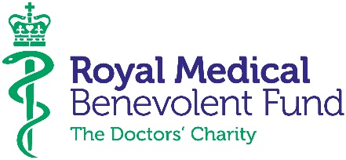

Community Fundraising Officer

The charity
The Royal Medical Benevolent Fund is the leading UK charity for doctors, medical students and their families. We provide financial support, money advice and information when it is most needed due to age, ill health, disability or bereavement.

The Role
This role is a great opportunity to harness your community fundraising experience to shape and expand our fundraising programme. You will be supporting an established group of fundraising guilds, as well as a network of committed young fundraising volunteers training to be doctors. You will help attract more individual and group supporters from in and around the medical community via medical conferences, workplace fundraising, social media activity, challenge events and more.
This role also assists with the individual giving programme and developing the RMBF's social media channels to reach more supporters and beneficiaries.
This is a very important role within the charity. Though we are a small team we always like to go above and beyond to look after our supporters and get to know them personally, so there’s room to have a big impact and have a very hands-on role.

Main duties and responsibilities

- Identify target fundraising groups in and around the medical profession including medical students, doctors and employees from partner organisations.
- Test the effectiveness of different fundraiser acquisition channels, taking a creative approach to digital and social media to attract new supporters.
- Provide dedicated support for all individual fundraisers and fundraising groups, including RMBF Guilds (regional groups who organise fundraising activities).
- Represent the charity at regional and national medical events, to raise awareness of the charity and help grow our community of supporters, fundraisers and volunteers.
- Work closely with the Volunteer Programme Manager to help inform our volunteers about local activities and encourage involvement where possible.
- Assist the Head of Fundraising & Communications with developing and stewarding the pipeline of individual givers and major donors.
- Assist with administration, planning and delivery of wider RMBF and departmental fundraising events.
- Carry out any other reasonable duties as specified by the Head of Fundraising and Communications and/or CEO.

Location: Wimbledon London SW19 with occasional UK travel. (Hybrid working trial with option for staff to work from home up to 2 days p/w)
Salary: £30,000 - £32,000
Benefits: Flexi-time system in operation; generous pension scheme; staff parking.
Reporting to: Head of Fundraising and Communications

This is a permanent, full-time position.

