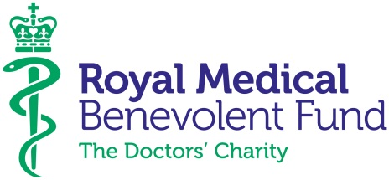
Elevator pitch
- The RMBF is the UK charity for doctors, medical students and their families
- Every day we provide help in times of crisis due to physical and mental ill health, injury, accident, disability and bereavement
- We provide tailor-made packages of financial support for beneficiaries including grants, loans and money advice services
- We are seeing more requests for help from doctors under the age of 40, who have not yet built up a financial safety net, making them particularly vulnerable to unexpected hardship
- With more and more doctors suffering from health related problems due to anxiety, stress and burnout, the broader suite of support that we offer is also invaluable
- This includes telephone befriending, DocHealth (a confidential psychotherapeutic consultation service co-funded with the BMA), and specialist coaching and mentoring for doctors returning to work
- Our 250+ volunteers visit our beneficiaries at home to ascertain their needs, provide support via phone, spread the word about the support we offer, and raise vital funds for the charity
- The RMBF has been helping doctors in need for over 180 years, and with your support we will continue to provide much-needed financial help in times of crisis
- We receive no government funding and our work is only made possible by the generosity of our supporters and volunteers

