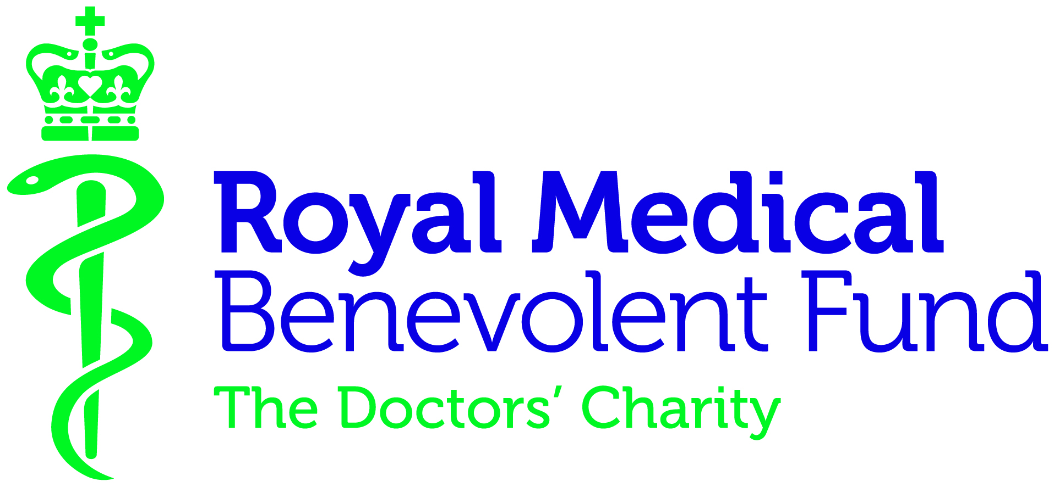
Case for support

The RMBF is the UK charity for doctors, medical students and their families.
For more than 180 years, we have helped members of the medical profession through times of hardship due to physical and mental ill health, injury, accident, disability and bereavement. Last year we supported over 200 beneficiaries by providing direct financial help, along with other services including back-to-work support.
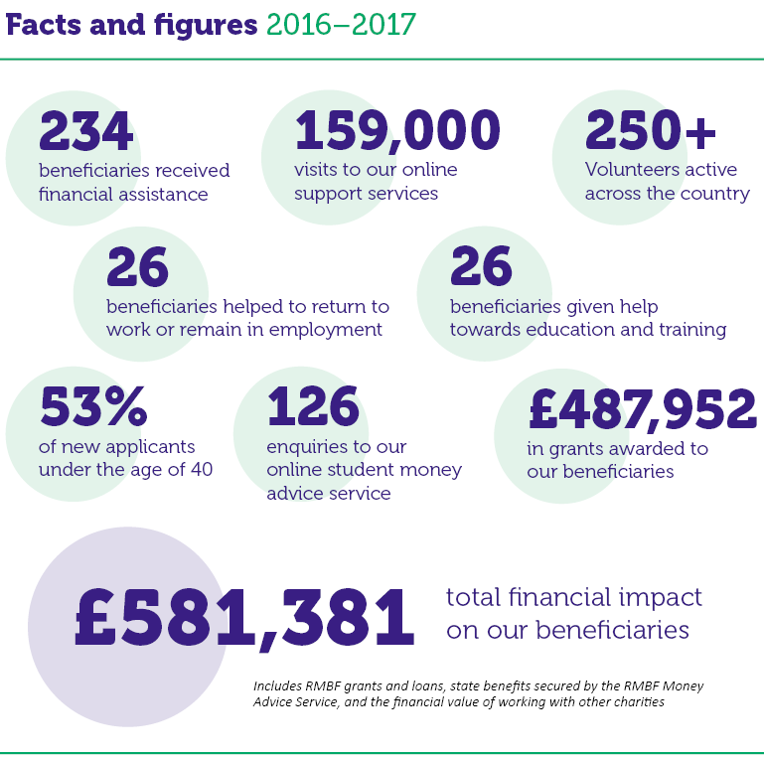
Did you know?
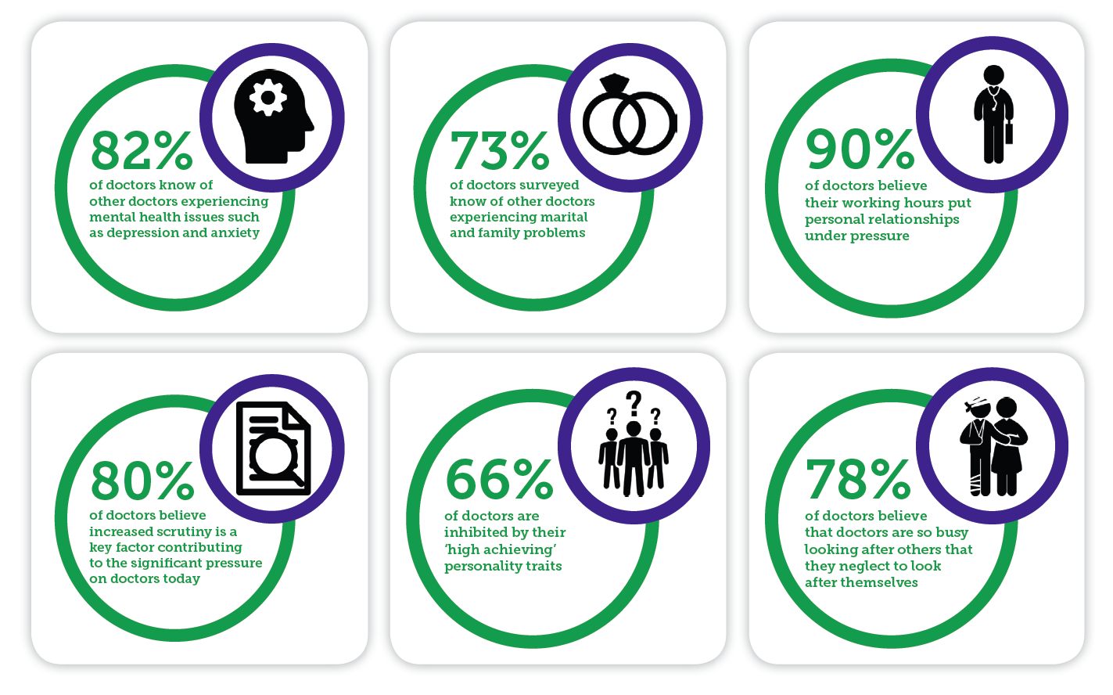
Doctors carry a greater suicide risk than the general population, with depression and work-related stress a common contributor
(General Medical Council)
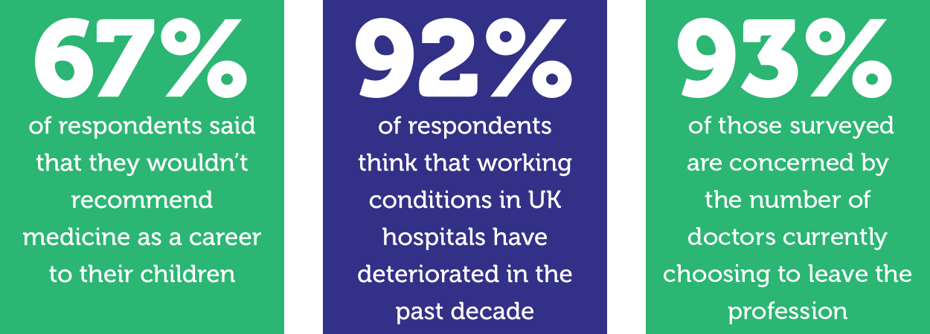
Statistics: RMBF campaign surveys, 2016 & 2017
Unfortunately this is the reality for the medical profession, and with increasing pressures on the NHS, there is a significant risk that things will continue to get worse.
In recent years, we have seen more requests for help from doctors under the age of 40. These are doctors who have not yet had the chance to build up a financial safety net and when faced with a crisis, through no fault of their own, need support. In 2012 we also expanded our support to cover medical students, providing financial help for those in unexpected hardship, as well as a dedicated online money advice service.
Why we need your support
We want to grow our services further, to ensure that we can provide the right support for our beneficiaries. We now provide more resources that can help doctors before they reach crisis point – our website offers advice on doctors’ health and wellbeing, as well as a series of guides that highlight common stress and pressure points for doctors. And it’s absolutely vital that we spread the word as widely as possible about the support the RMBF can offer, so that every doctor and medical student in the UK knows where to seek help if the worst happens.
We rely on voluntary donations and receive no government funding. With your support, the RMBF can continue to ensure that doctors, medical students and their families will always have somewhere to turn in times of crisis.
Case study: Dr Thomas
Dr Thomas was suffering with depression and anxiety, and he had been out of work for six years. He approached the RMBF because he needed help getting back to work. Returning to medical work after such a long absence meant Dr Thomas was required to do the GP Induction and Refresher scheme. The RMBF paid for the assessments and examinations that were part of the scheme, as well as other back to work costs. Two years later he was back on the GP Performers’ list and starting a new job. The RMBF also helped with living expenses while he was out of work, and provided one of his sons with a student grant for his first year studying at university.
“Thank you sincerely for all your help, kindness and support through the difficult years. I will never be able to repay what the RMBF has done for me… It is difficult to put into words the positive impact you have had during this difficult period of my life and my wife and children’s lives. Please keep up the good work you are doing.”
Case study: Elizabeth
Whilst in her final year at medical school, Elizabeth was involved in a road accident and had to use a wheelchair for three months. She was unable to return to her studies in time to sit her final exams and was forced to re-start her final year. The added financial pressure of an extra year studying meant that Elizabeth was finding it increasingly difficult to make ends meet.
Elizabeth’s medical school welfare team recommended her for the RMBF’s Medical Student Project. The RMBF helped Elizabeth through her final year. Elizabeth passed her exams and subsequently started her F1 post.
“Without the help of the RMBF I would have struggled to complete the course due to financial pressure. Thanks to them I was able to focus on exams and not have to worry about finances.”

Our Volunteers
Our network of over 250 Volunteers plays an essential role in the charity’s work. Most of our Volunteers, as well as our board of Trustees, are from a medical background, so as an organisation we understand the unique pressures facing doctors on a day-to-day basis.
Volunteer roles
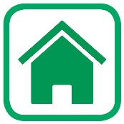
Area Visitor
Area Visitors act as local contacts to our beneficiaries around the country. Their role involves:
- Visiting applicants and beneficiaries at home
- Helping our beneficiaries to understand the kind of support that the RMBF can consider
- Preparing reports for the Grants and Awards Committee, to help them decide how we can best allocate our support
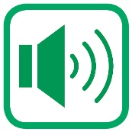
Medical Liaison Officer
Medical Liaison Officers raise the RMBF’s profile and make sure those who need help know where to turn. Their role involves:
- Liaising with hospitals, medical centres and societies in their area
- Using their experience and contacts to help raise the RMBF’s profile
- Keeping us up to date with the issues affecting doctors and their families locally, so our help remains relevant across the UK
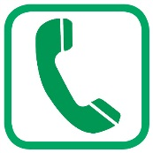
PhoneFriend
The RMBF PhoneFriend scheme helps doctors and their families who feel isolated and in need of support. Our PhoneFriend volunteers provide regular friendly chats over the phone offering emotional support wherever it is needed in the UK.
Guild Supporter
The RMBF’s local community fundraising volunteers are arranged into Guilds. Each year the Guild volunteers organise local fundraising events and help spread the message about the RMBF. Most of the Guild members are from medical backgrounds or medical families, and the events are always great fun and a fantastic way to raise money for the RMBF.
Guilds are usually run by a small committee, who are always keen to recruit new officers to help out.
For more information on volunteering, please contact Kate Sheppard on ksheppard@rmbf.org or 020 3255 3003.

